Bahria University,

Karachi Campus



LAB EXPERIMENT NO.

**06**

LIST OF TASKS

|  |  |
| --- | --- |
| TASK NO | OBJECTIVE |
| 1 | **Taking composite choice from the user using checkboxes** |
| 2 | **ColorChanger using RadioButton** |
| 3 | **Show the choices in TextView** |

**Task 1: Taking composite choice from the user using checkboxes**

**Design**

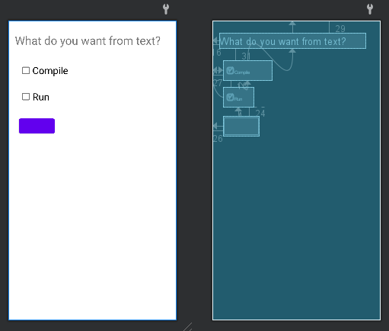

**Code**

public class MainActivity extends AppCompatActivity {

private Button btn;

private CheckBox chk1;

private CheckBox chk2;

private String txt1="";

@Override

protected void onCreate(Bundle savedInstanceState) {

super.onCreate(savedInstanceState);

setContentView(R.layout.activity_main);

btn=findViewById(R.id.button);

chk1=findViewById(R.id.checkBox);

chk2=findViewById(R.id.checkBox2);

String chkBox1=chk1.getText().toString();

String chkBox2=chk2.getText().toString();

chk1.setOnCheckedChangeListener(new CompoundButton.OnCheckedChangeListener() {

@Override

public void onCheckedChanged(CompoundButton compoundButton, boolean b) {

if(chk1.isChecked()){

if(btn.getText().toString()!=""){

txt1+="+"+chkBox1;

else{

txt1+=chkBox1;}}

else{

txt1=txt1.replace(chkBox1,"");

if (txt1.contains("+")){

txt1=txt1.replace("+","");}}

btn.setText(txt1);}});

chk2.setOnCheckedChangeListener(new CompoundButton.OnCheckedChangeListener() {

@Override

public void onCheckedChanged(CompoundButton compoundButton, boolean b) {

if(chk2.isChecked()){

if(btn.getText().toString()!=""){

txt1+="+"+chkBox2;

}

else{

txt1+=chkBox2;}}

else{

txt1=txt1.replace(chkBox2,"");

if (txt1.contains("+")){

txt1=txt1.replace("+","");}}

btn.setText(txt1);}}});

btn.setOnClickListener(new View.OnClickListener() {

@Override

public void onClick(View view) {

Toast.makeText(MainActivity.this, btn.getText().toString(), Toast.LENGTH_SHORT).show();}})}};

**Output**

**Task 2: ColorChanger using RadioButton**

**Design**

**Code**

public class MainActivity extends AppCompatActivity {

private RadioButton redB;

private RadioButton redF;

private RadioButton greenB;

private RadioButton greenF;

private RadioButton blueB;

private RadioButton blueF;

@Override

protected void onCreate(Bundle savedInstanceState) {

super.onCreate(savedInstanceState);

setContentView(R.layout.activity_main);

redB=findViewById(R.id.Red);

redF=findViewById(R.id.RedF);

greenB=findViewById(R.id.Green);

greenF=findViewById(R.id.GreenF);

blueB=findViewById(R.id.Blue);

blueF=findViewById(R.id.BlueF);

View.OnClickListener backgroundClickListener = new View.OnClickListener() {

@Override

public void onClick(View view) {

switch (view.getId()) {

case R.id.Red:

getWindow().getDecorView().setBackgroundColor(Color.RED);

break;

case R.id.Green:

getWindow().getDecorView().setBackgroundColor(Color.GREEN);

break;

case R.id.Blue:

getWindow().getDecorView().setBackgroundColor(Color.BLUE);

break;

}}}}

View.OnClickListener foregroundClickListener = new View.OnClickListener() {

@Override

public void onClick(View view) {

switch (view.getId()){

case R.id.GreenF:

getWindow().getDecorView().setForeground(new ColorDrawable(Color.GREEN));

break;

case R.id.BlueF:

getWindow().getDecorView().setForeground(new ColorDrawable(Color.BLUE));

break;

case R.id.RedF:

getWindow().getDecorView().setForeground(new ColorDrawable(Color.RED));}}

}

redB.setOnClickListener(backgroundClickListener);

greenB.setOnClickListener(backgroundClickListener);

blueB.setOnClickListener(backgroundClickListener);

redF.setOnClickListener(foregroundClickListener);

greenF.setOnClickListener(foregroundClickListener);

blueF.setOnClickListener(foregroundClickListener);

**Output**

**Task 3: Show the choices in TextView**

**Design**

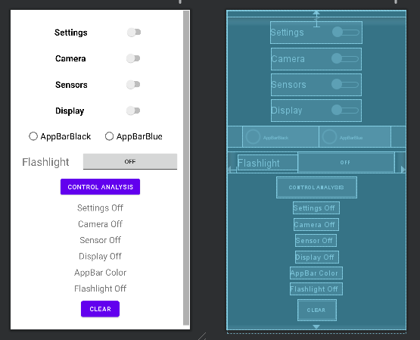

**Code**

public class MainActivity extends AppCompatActivity {

private TextView settingText,cameraText,sensorText,displayText,appBarText,flashText;

private ToggleButton toggleButton1;

private Switch switch1,switch2,switch3,switch4;

private RadioGroup radioGroup;

private RadioButton rbtn1,rbtn2;

@SuppressLint("MissingInflatedId")

@Override

protected void onCreate(Bundle savedInstanceState) {

super.onCreate(savedInstanceState);

setContentView(R.layout.activity_main);

settingText=findViewById(R.id.settingText);

cameraText=findViewById(R.id.cameraText);

sensorText=findViewById(R.id.sensorText);

displayText=findViewById(R.id.displayText);

appBarText=findViewById(R.id.appText);

flashText=findViewById(R.id.lightText);

toggleButton1=findViewById(R.id.toggleButton);

switch1=findViewById(R.id.switch2);

switch2=findViewById(R.id.switch3);

switch3=findViewById(R.id.switch4);

switch4=findViewById(R.id.switch5);

radioGroup=findViewById(R.id.radioGroup);

rbtn1=findViewById(R.id.radioButton3);

rbtn2=findViewById(R.id.radioButton4);

switch1.setOnCheckedChangeListener(new CompoundButton.OnCheckedChangeListener() {

@Override

public void onCheckedChanged(CompoundButton compoundButton, boolean b) {

if(b){

settingText.setText("Settings On");

}

else{

settingText.setText("Settings Off");}}}

switch2.setOnCheckedChangeListener(new CompoundButton.OnCheckedChangeListener() {

@Override

public void onCheckedChanged(CompoundButton compoundButton, boolean b) {

if(b){

cameraText.setText("Camera On");}

else{

cameraText.setText("Camera Off");}}});

switch3.setOnCheckedChangeListener(new CompoundButton.OnCheckedChangeListener() {

@Override

public void onCheckedChanged(CompoundButton compoundButton, boolean b) {

if(b){

sensorText.setText("Sensors On");

}

else{

sensorText.setText("Sensors Off");}}});

switch4.setOnCheckedChangeListener(new CompoundButton.OnCheckedChangeListener() {

@Override

public void onCheckedChanged(CompoundButton compoundButton, boolean b) {

if(b){

displayText.setText("Display On");

}

else {

displayText.setText("Display Off");}}}):

radioGroup.setOnCheckedChangeListener(new RadioGroup.OnCheckedChangeListener() {

@Override

public void onCheckedChanged(RadioGroup radioGroup, int i) {

if(i==rbtn1.getId()){

appBarText.setText("AppBar Black");

} else if (i==rbtn2.getId()) {

appBarText.setText("AppBar Blue");}}});

toggleButton1.setOnCheckedChangeListener(new CompoundButton.OnCheckedChangeListener() {

@Override

public void onCheckedChanged(CompoundButton compoundButton, boolean b) {

if(b){

flashText.setText("Flashlight On");

}

else{

flashText.setText("Flashlight Off");

}}});

**Output**

